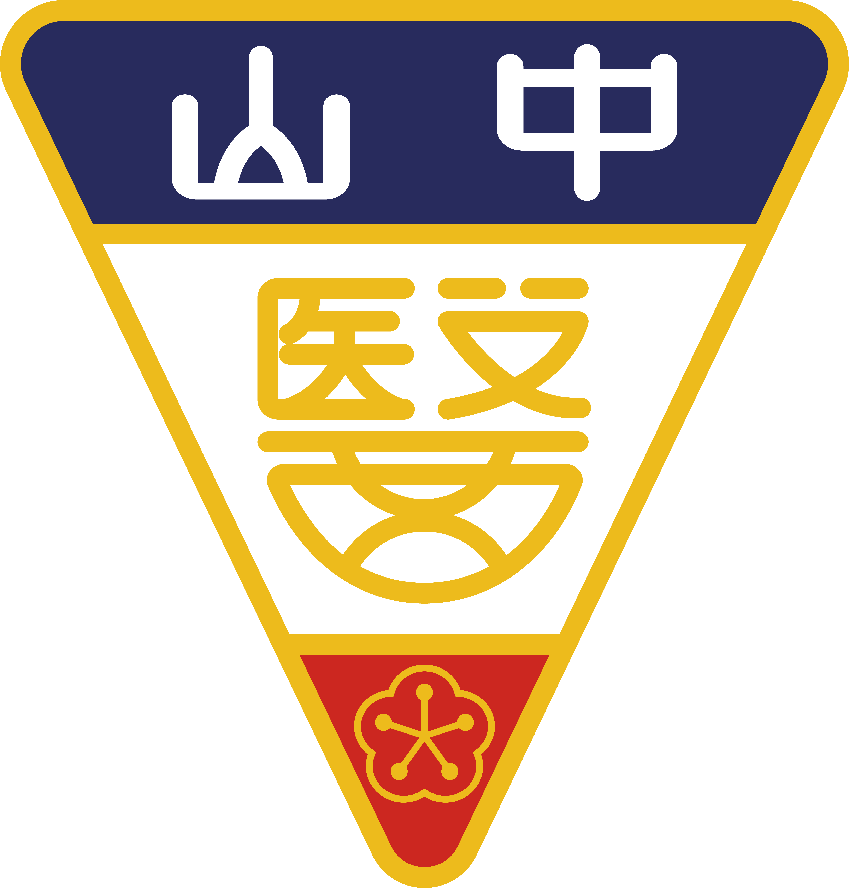 | Bridging the Gap in OMFS: Innovations and Challenges in TMJ Disorders and Orthognathic Surgery  Abstract Submission Form | 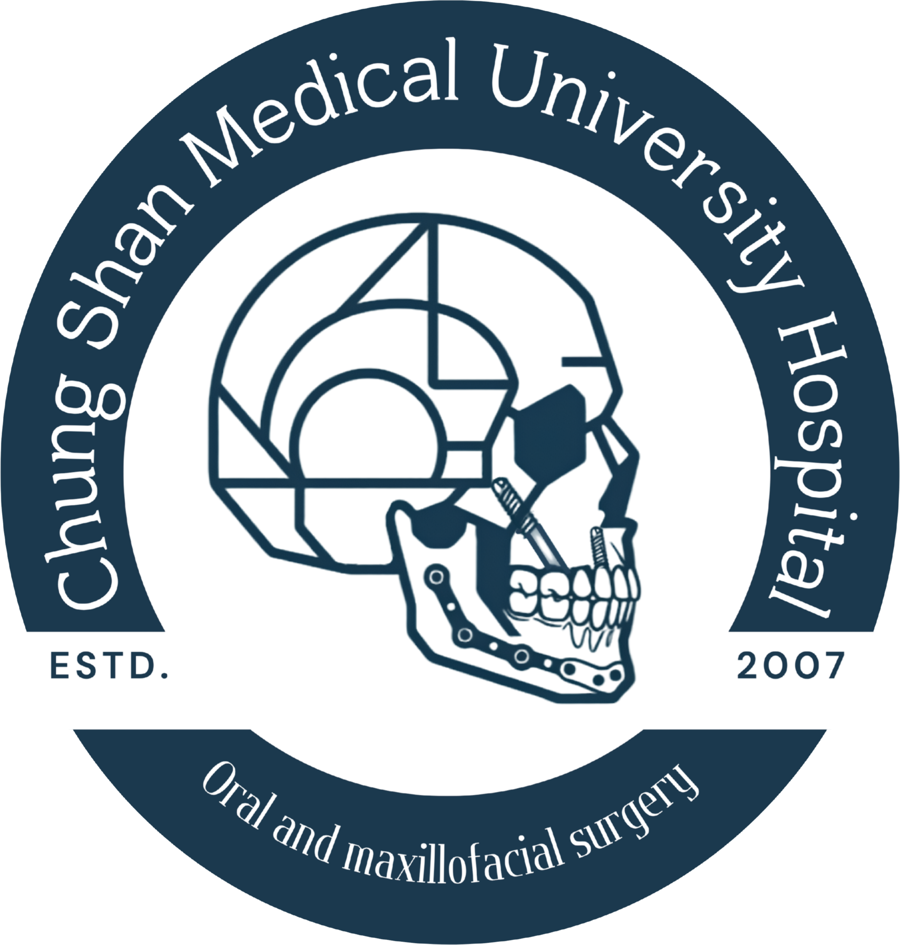

Please complete this form and email it to cs5011@csmu.edu.tw by October 15, 2026, 12:00 PM (Noon).
First Name
Last Name
Abstract Title
Authors
Maximum of 10 authors. Please underline the presenting author.
Affiliations
Maximum of 10 affiliations. Must include department, institution/hospital, and country.
Abstract Body
Max 400 words. Must NOT include tables, images, or references.
[ Please type your abstract here... ]

